DL Lab Exp No.4 (Mini Project)

- Colourizing B&W to colourful images:

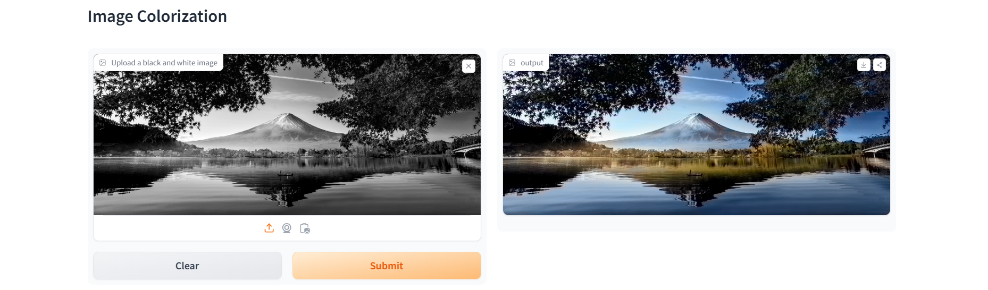

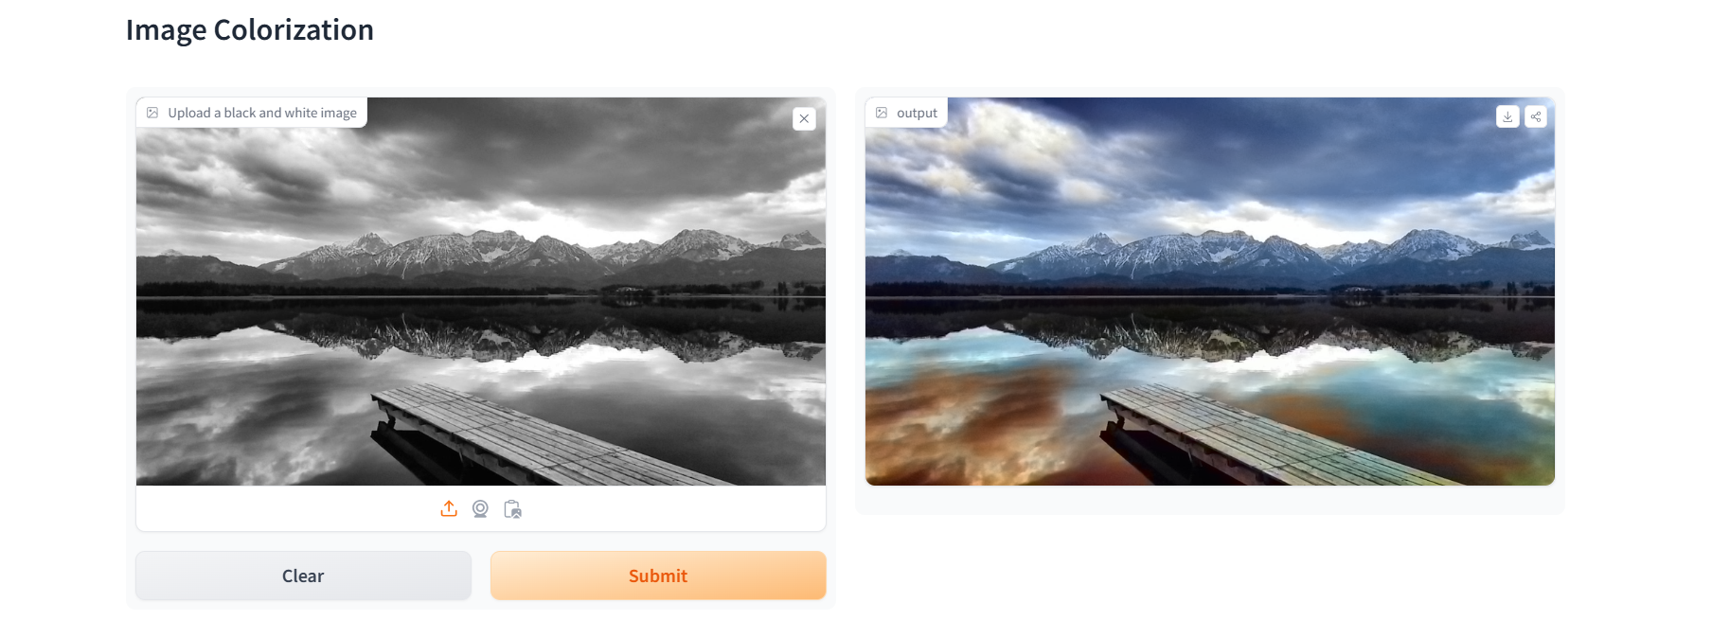
- Gender and Age Detection:

